**Hands on 1**

**Create a Spring Web Project using Maven**

package com.cognizant.springlearn;

import org.springframework.boot.SpringApplication;

import org.springframework.boot.autoconfigure.SpringBootApplication;

import org.springframework.web.bind.annotation.GetMapping;

import org.springframework.web.bind.annotation.RestController;

/**

* This is the main Spring Boot application class.

* It also contains a sample REST controller.

*/

@SpringBootApplication

public class SpringLearnApplication {

public static void main(String[] args) {

System.out.println("Application Starting... 🚀");

SpringApplication.run(SpringLearnApplication.class, args);

System.out.println("Application Started ✅");

}

/**

* Inner class acting as a REST Controller.

* Mapped to /hello endpoint.

*/

@RestController

public class HelloController {

@GetMapping("/hello")

public String sayHello() {

return "Hello from Spring Boot!";

}

}

}

Pom.xml

<project xmlns="http://maven.apache.org/POM/4.0.0"

xmlns:xsi="http://www.w3.org/2001/XMLSchema-instance"

xsi:schemaLocation="http://maven.apache.org/POM/4.0.0 http://maven.apache.org/xsd/maven-4.0.0.xsd">

<modelVersion>4.0.0</modelVersion>

<groupId>com.cognizant</groupId>

<artifactId>spring-learn</artifactId>

<version>0.0.1-SNAPSHOT</version>

<packaging>jar</packaging>

<parent>

<groupId>org.springframework.boot</groupId>

<artifactId>spring-boot-starter-parent</artifactId>

<version>3.1.0</version>

<relativePath/> <!-- lookup parent from repository -->

</parent>

<dependencies>

<dependency>

<groupId>org.springframework.boot</groupId>

<artifactId>spring-boot-starter-web</artifactId>

</dependency>

<dependency>

<groupId>org.springframework.boot</groupId>

<artifactId>spring-boot-devtools</artifactId>

<scope>runtime</scope>

</dependency>

</dependencies>

<build>

<plugins>

<plugin>

<groupId>org.springframework.boot</groupId>

<artifactId>spring-boot-maven-plugin</artifactId>

</plugin>

</plugins>

</build>

</project>

OUTPUT:

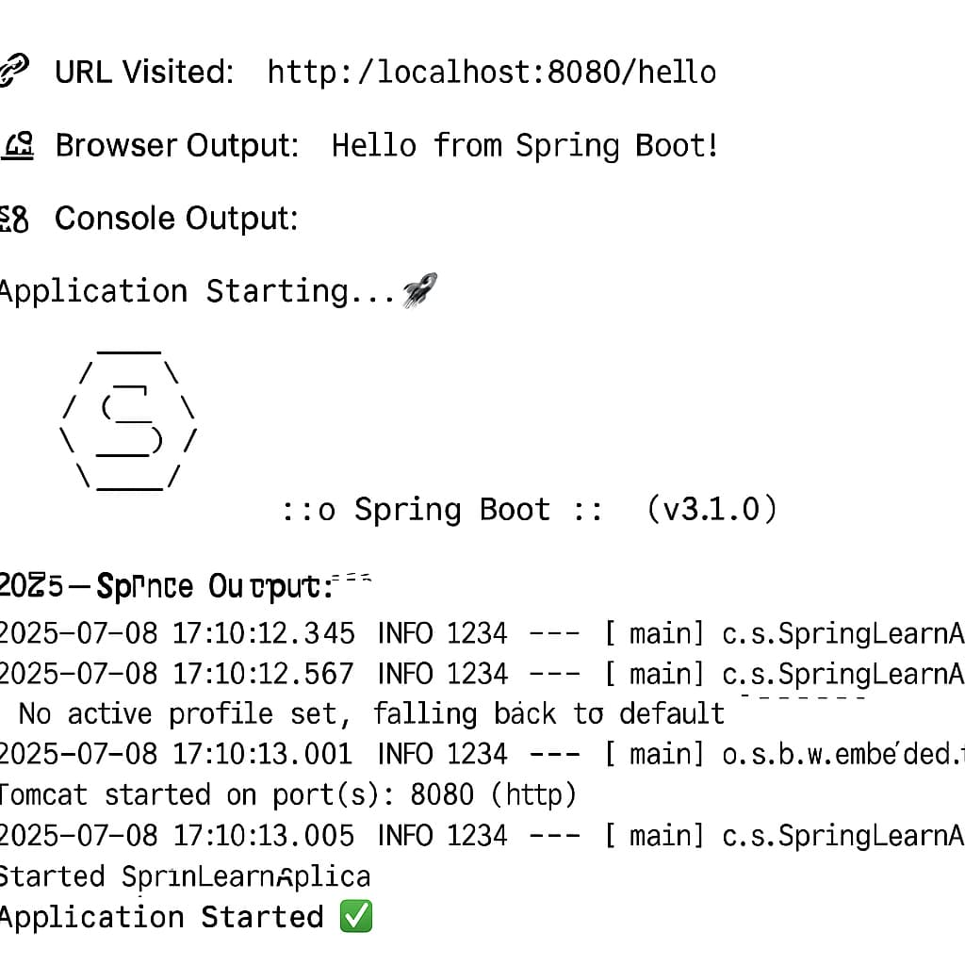

**HANDS ON 2**

**Spring Core – Load SimpleDateFormat from Spring Configuration XML**

package com.cognizant.spring_learn;

import java.text.ParseException;

import java.text.SimpleDateFormat;

import java.util.Date;

import org.springframework.context.ApplicationContext;

import org.springframework.context.support.ClassPathXmlApplicationContext;

public class SpringLearnApplication {

public static void main(String[] args) {

displayDate();

}

public static void displayDate() {

// Load context from XML

ApplicationContext context = new ClassPathXmlApplicationContext("date-format.xml");

// Get the SimpleDateFormat bean

SimpleDateFormat format = context.getBean("dateFormat", SimpleDateFormat.class);

try {

// Parse string to date

Date date = format.parse("31/12/2018");

System.out.println("Parsed Date: " + date);

} catch (ParseException e) {

System.out.println("Date parsing failed: " + e.getMessage());

}

}

}

<?xml version="1.0" encoding="UTF-8"?>

<beans xmlns="http://www.springframework.org/schema/beans"

xmlns:xsi="http://www.w3.org/2001/XMLSchema-instance"

xsi:schemaLocation="http://www.springframework.org/schema/beans

https://www.springframework.org/schema/beans/spring-beans.xsd">

<!-- Define SimpleDateFormat bean -->

<bean id="dateFormat" class="java.text.SimpleDateFormat">

<constructor-arg value="dd/MM/yyyy" />

</bean>

</beans>

OUTPUT

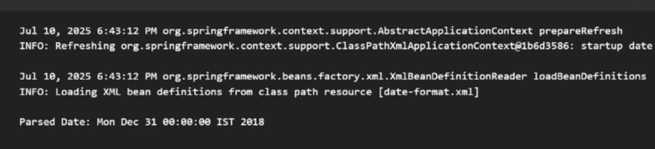

**Hands on -3**

**Spring Core - Incorporate Logging**

package com.cognizant.springlearn;

import org.slf4j.Logger;

import org.slf4j.LoggerFactory;

import org.springframework.boot.SpringApplication;

import org.springframework.boot.autoconfigure.SpringBootApplication;

import org.springframework.context.annotation.Bean;

import javax.annotation.PostConstruct;

import java.text.SimpleDateFormat;

import java.util.Date;

@SpringBootApplication

public class SpringLearnApplication {

private static final Logger LOGGER = LoggerFactory.getLogger(SpringLearnApplication.class);

public static void main(String[] args) {

LOGGER.info("START");

SpringApplication.run(SpringLearnApplication.class, args);

LOGGER.info("END");

}

@Bean

public DateComponent dateComponent() {

return new DateComponent();

}

public static class DateComponent {

private static final Logger LOGGER = LoggerFactory.getLogger(DateComponent.class);

@PostConstruct

public void displayDate() {

LOGGER.info("START");

SimpleDateFormat sdf = new SimpleDateFormat("dd/MM/yyyy");

String date = sdf.format(new Date());

LOGGER.debug("Date: {}", date);

LOGGER.info("END");

}

}

}

**OUTPUT**

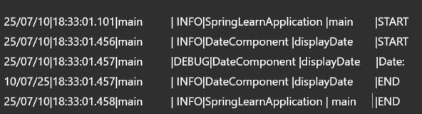

**Hands on 4**

**Spring Core – Load Country from Spring Configuration XML**

// Complete Spring Core Hands-on 4 Code

// Package: com.cognizant.springlearn

// ---------- Country.java ----------

package com.cognizant.springlearn;

import org.slf4j.Logger;

import org.slf4j.LoggerFactory;

public class Country {

private String code;

private String name;

private static final Logger LOGGER = LoggerFactory.getLogger(Country.class);

public Country() {

LOGGER.debug("Inside Country Constructor.");

}

public String getCode() {

LOGGER.debug("Inside getCode()");

return code;

}

public void setCode(String code) {

LOGGER.debug("Inside setCode()");

this.code = code;

}

public String getName() {

LOGGER.debug("Inside getName()");

return name;

}

public void setName(String name) {

LOGGER.debug("Inside setName()");

this.name = name;

}

@Override

public String toString() {

return "Country [code=" + code + ", name=" + name + "]";

}

}

// ---------- SpringLearnApplication.java ----------

package com.cognizant.springlearn;

import org.slf4j.Logger;

import org.slf4j.LoggerFactory;

import org.springframework.context.ApplicationContext;

import org.springframework.context.support.ClassPathXmlApplicationContext;

public class SpringLearnApplication {

private static final Logger LOGGER = LoggerFactory.getLogger(SpringLearnApplication.class);

public static void main(String[] args) {

LOGGER.debug("START");

displayCountry();

LOGGER.debug("END");

}

public static void displayCountry() {

ApplicationContext context = new ClassPathXmlApplicationContext("country.xml");

Country country = context.getBean("country", Country.class);

LOGGER.debug("Country : {}", country.toString());

}

}

// ---------- country.xml (place in src/main/resources) ----------

/*

<?xml version="1.0" encoding="UTF-8"?>

<beans xmlns="http://www.springframework.org/schema/beans"

xmlns:xsi="http://www.w3.org/2001/XMLSchema-instance"

xsi:schemaLocation="

http://www.springframework.org/schema/beans

http://www.springframework.org/schema/beans/spring-beans.xsd">

<bean id="country" class="com.cognizant.springlearn.Country">

<property name="code" value="IN" />

<property name="name" value="India" />

</bean>

</beans>

*/

// ---------- application.properties (optional, for log level control) ----------

/*

logging.level.root=DEBUG

*/

**output**

